LEAGUE OF WOMEN VOTERS OF CENTRE COUNTY

NEWSLETTER

Volume 65 Number 3 FALL 2019

Calendar of League of Women Voters of Centre County

20 Oct. CC-United Nations Association Dinner
29 Oct Deadline to Apply for Absentee Ballot

1 Nov. Deadline for receipt of Absentee Ballots
5 Nov. Municipal Elections
6 Nov. Begin voter registration post-election
12 Nov. Deadline for Receipt of Military and Overseas Ballots
19 Nov. Steering Committee Meeting, noon, State College Municipal Building

3 Dec. Steering Committee Meeting – Steering Committee members only
13 Dec. Holiday Luncheon – Foxdale
17 Dec. Steering Committee Meeting, noon, State College Municipal Building

From the Desk of a Presiding Officer

What a busy time!

Please take time from your busy schedule to look at our newly designed website at lwvcentrecounty.org. Lori Weider and Laura Brown worked tirelessly to re-design our website to offer more information and make it more easily accessible.
September and October saw us participating in a record number of voter registration events, including Constitution Day and National Voter Registration Day. We sought and received permission to participate in Constitution Day, registering voters at the HUB on campus. A special thank you to our volunteers: Laura Brown, Sara Bresler, Marion Sheridan, Sue Smith, Lori Wieder, Betsy Whitman, Brucie and James Serene and Rick Sargo.

Candidates’ Nights went well. A special thank you to Sue Werner who once again organized and guided us through our signature event. Thank you to the moderators, screeners, and runners who helped to make sure everything ran smoothly: Stephanie Yager, Jennifer Nicholas, Lydia Vandenbergh, Marion Sheridan, Sara Bresler, Don Hahn, and Laura Brown.

The Voter’s Guide is in the works and you can expect to see it published in the Centre Daily Times again in advance of the November election. Shout out to Sara Bresler who not only compiles and ensures the publication of the guide but also coordinates the input so that Vote411.org houses all the relevant candidate information for our Centre County elections.

Our Town Halls are set to launch shortly with the first of our four town halls: “Why Courts Matter.” It will be held in October16th at 7PM at Penns Valley Area High School Auditorium. We’re pleased to have Centre County District Attorney Bernie Cantorna, Judges Katie Oliver and Tom Jordan and Attorney Stephanie Cooper as our panelists. It will be an interesting evening! Come and bring your neighbors. Students are welcome also!

To fund the town halls, an internship, and other outreach efforts we will be launching a fundraising campaign in November. Expect to hear from us and please do what you can to support our mission.

Be sure to keep your membership active & encouraging family, friends, coworkers & neighbors to join as well. 2020 will be a big year for us, not only as a presidential election year but as the commemoration of our 100th birthday of the LWV and the ratification of the 19th amendment.

Have a wonderful holiday season!
Jan

New website!

Check out our new website at http://lwvcentrecounty.org/. It was developed with these goals in mind:
· Make clear LWV mission and policies
· Stimulate membership and involvement in LWVCC
· Provide resources to engage and educate voters
· Encourage active and engaged citizenship

Consider sharing the site with friends to invite their participation in the League.

Thank you to Lori Wieder for contributing her time and expertise to develop the site. Laura Brown has worked on content and she will be working with Lori to maintain it. They need your help! Please send your feedback and suggestions to LauraSBrown76@gmail.com.

Hats off to Cindy Hahn who has faithfully maintained the site for many years.

Did you miss Candidates’ Nights?

The October 1st and October 2nd League of Women Voters' Candidates' Nights for the 2019 General Election is now available to view online at cnet1.org or on our website: https://www.lwvcentrecounty.org/

Vote411.org

The LWV Vote411.org website has been populated and redone. Please take a look. You can access information on how to register to vote, absentee ballots, sample ballots for the upcoming election, and a guide for first time voters. https://www.vote411.org/

Engaging Student Voters
The League of Women Voters, National, State and our local chapter are all waiving the membership fee for student members through 2021. Since membership can begin at age 16, we look forward to your support in reaching out to younger student voters and potential student voters. Membership in the league may make a nice graduation or back-to-school gift for eligible students.

Young Adults, non-students under the age of 35, can become members of the National, State and our local chapter for a reduced fee of $35.

Current members are our best recruiters!! Gift memberships are welcome.

Update from National (LWVUS)

The national League has launched an online campaign to re-introduce the League to new
audiences in our 100th year. This exciting campaign is called She Is Me, and it features stories of
our real League members, their work, and their commitment to defending democracy with our
organization. You can check out this new campaign through the link on the homepage of our
website, www.lwvcentrecounty.org

This month the National League unveiled People Powered Fair Maps™, a coordinated effort across all 50 states and the District of Columbia to create fair and transparent district maps nationwide.
In June 2019, the Supreme Court ruled in Rucho v. League of Women Voters of North Carolina and companion cases that there is no fair test to determine when partisan gerrymandering has gone too far.
When the Supreme Court ruled that federal courts could not play a role in policing partisan gerrymandering, it presented an opportunity for us to lead a national conversation about other fixes to this flaw in our democracy.
As a long-time leader on redistricting, the League has played a major role in establishing nonpartisan redistricting commissions and effectively challenging the enforcement of an equitable process for district map creation. This campaign is a powerful collaboration between more than 750 Leagues at national, state, and local levels, aimed at ensuring democracy works for us all in 2021 and beyond.

Monthly Steering Committee Meetings are usually held on the third Tuesday of the month at
noon at the State College Municipal Building. All members are welcome! This is a wonderful
opportunity to become more involved and bring to light issues you believe should be addressed.
If you plan on attending, please email either Jan Koch (jankkoch@gmail.com) or Sue Sargo
(ssargo4@gmail.com) so we may welcome you.

Town Hall: Why Courts Matter – October 16

You should be seeing our flyers on social media and throughout Centre County. Help us ensure
a large turnout by sharing the flyer (below) and information about our town hall with your friends
and neighbors. Please come and join us for what looks to be an informative town hall!

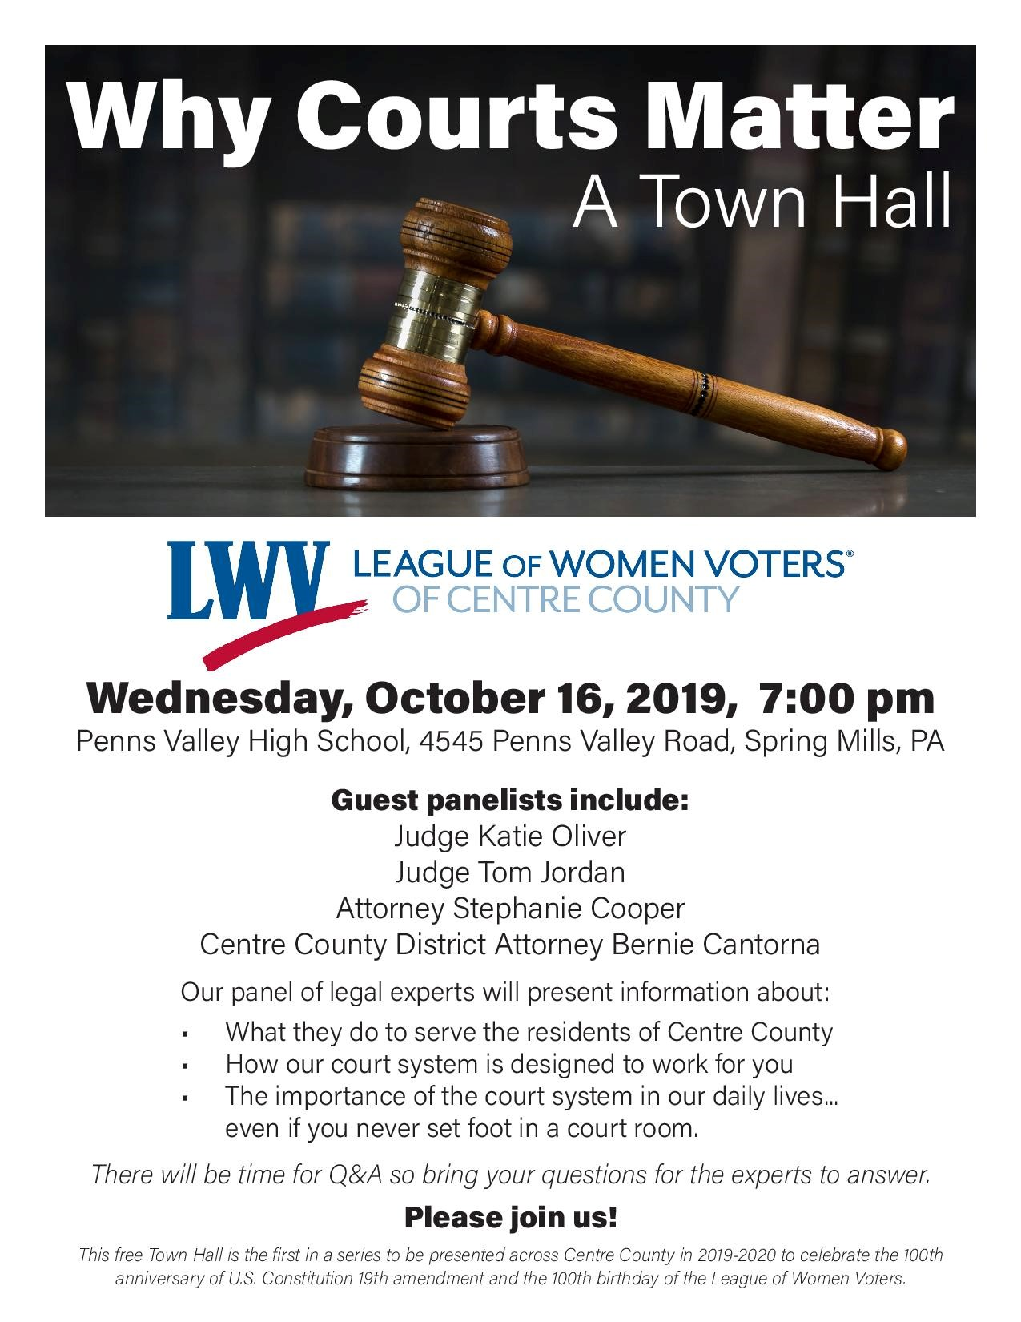
.

We’re looking for Volunteers – a day or a few hours a month:

Civic Education Forums: Sue Sargo is leading the planning for our civic education forums. If you’re interested in participating, please contact Sue at ssargo4@gmail.com

Social Media: We need some savvy volunteers to help with posting and updating of our social media accounts. If interested contact Jan Koch jankkoch@gmail.com

VotePSU: Interested in helping to engage Penn State voters? Laura Brown is looking for
volunteers for her committee. Familiarity with the university would be very helpful. Contact Laura at laurasbrown76@gmail.com

Follow us:
Website: lwvcentrecounty.org
Facebook: League of Women Voters of Centre County
Twitter: lwvcentrecounty
Instagram: lwvcentrecounty

LWVCC OFFICERS
Co-Presiding Officers - Jan Koch and Sue Sargo
Secretary - Marion Sheridan
Treasurer - Sue Floyd

LEAGUE OF WOMEN VOTERS OF CENTRE COUNTY
P.O. BOX 962
STATE COLLEGE PA 16804-0962

